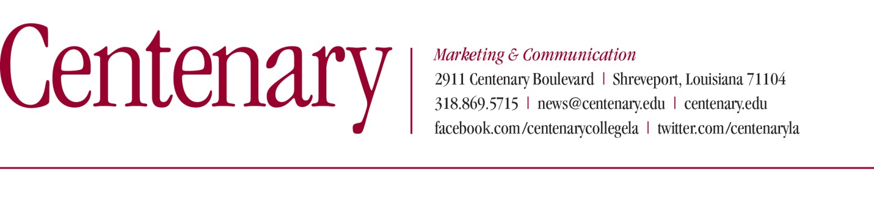
MEDIA RELEASE- FOR IMMEDIATE RELEASE (August 20, 2019)
Contact: Kate Pedrotty, Centenary Marketing & Communication, 318.869.5715

Centenary Youth Orchestra auditions set to begin August 23
SHREVEPORT, LA — The Centenary Youth Orchestra (CYO) and conductor Daniel Santelices announce that auditions are now open for student musicians, 13 years of age and up, desiring to be a part of the CYO for the 2019-2020 season. The CYO provides a unique opportunity to perform side-by-side with college-level musicians attending Centenary College of Louisiana. Rehearsals begin Monday, September 9, from 7:00-8:30 p.m. at the Hurley School of Music in Feazel Rehearsal Hall.
Auditions will take place at the Hurley School of Music according to the following schedule:
- Friday, August 23 and Sunday, August 25 - 4:00-6:00 p.m.
- Monday, August 26 - 6:00-8:30 p.m.
- Monday September 2 - 10:00 a.m. – 12:00 p.m. (noon)
- Sunday, September 8 - 2:00-6:00 p.m.
Auditions may also be scheduled by appointment for those unable to attend those dates.
Audition requirements for bowed-stringed instruments, woodwind, and brass instruments will consist of one major and minor scale, a solo selection of two to three minutes, prepared orchestra excerpts selected by the conductor, and sight reading. Keyboard/piano, harp, timpani and percussion players need to also prepare a short solo selection and requested orchestra excerpts. Please contact the CYO at dsantelices@centenary.edu or call the Hurley School of Music office at 318.869.5235 to schedule an audition and obtain an audition packet.
CYO concerts for the 2019-2020 season will take place at 2:30 p.m. on Sunday, November 17, 2019, and Sunday March 8, 2020, in Anderson Auditorium.
The November 17 opening concert will feature CYO oboist Hannah Hobson in a performance of the Concerto in C-minor by the Baroque composer, Alessandro Marcello. Hobson attends Caddo Magnet High School and studies privately with Shreveport Symphony principal oboe and Hurley School of Music faculty, Theresa Zale-Bridges. The CYO will also perform Georg Fredric Handel's ebullient Arrival of the Queen of Sheba and Pietro Mascagni's lush Intermezzo from his opera Cavalleria Rusticana. Tschaikovsky's charming music from ballet, The Nutcracker, and the finale movement to Sibelius' Symphony No. 2 will complete the program.
"From the sublime beauty of the Marcello to the grandeur of the full orchestra effect of the Sibelius, the audience is sure to be transported through a variety of emotional states,” says Santelices.
Santelices is also excited to announce the inaugural CYO Concerto Competition which will be open only to CYO members. The competition will be held Saturday, October 19, 2019. The winner(s) will play with the CYO at the March 8, 2020 concert.
"One of my goals in establishing the competition is to encourage our members in their pursuit of musical excellence,” explains Santelices. “For some musicians, it may be a once-in-a-lifetime opportunity to play a solo with an orchestra."
###
About Centenary College of Louisiana

Centenary College of Louisiana is a selective, residential, national liberal arts college affiliated with the United Methodist Church. Founded in 1825, it is the oldest chartered liberal arts college west of the Mississippi River and is a member of the Associated Colleges of the South.

