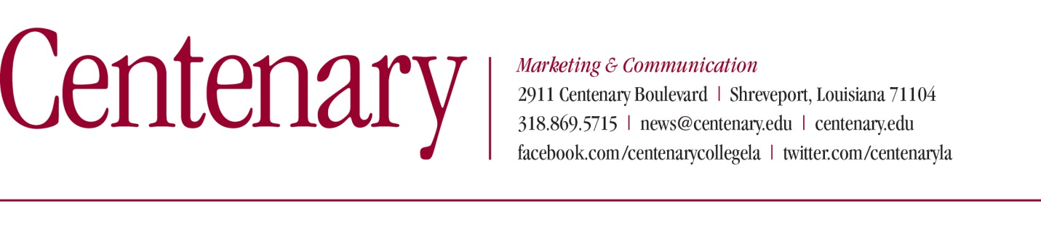
MEDIA RELEASE- FOR IMMEDIATE RELEASE (March 2, 2020)
Contact: Kate Pedrotty, Centenary Marketing & Communication, 318.869.5715

Centenary Youth Orchestra to perform March 8
SHREVEPORT, LA — The winners of the inaugural Centenary Youth Orchestra (CYO) Concerto Competition and the C.E. Byrd High School Choir will be featured performers for the upcoming CYO concert on March 8 at 2:00 p.m. in Anderson Auditorium at Centenary’s Hurley School of Music. CYO senior members will also be recognized and honored during the program. The concert is free and open to the public.
“There is so much to be excited about for this concert,” says CYO conductor Daniel Santelices. “It is a pleasure to have a Centenary alumna, Rebecca Kay Vacha, and her Byrd High School choir join us in performing ‘Come In’ and ‘A Girls Garden’ which are from noted American composer Randal Thompson’s piece Frostiana. Rebecca had approached me about this collaboration last year. I also wanted to offer her the opportunity to make her orchestral conducting debut with the CYO. She is doing remarkable work with her choir and the CYO members have immediately taken a liking to her.”

The two Frostiana songs to be performed are from a 1959 commission for the bicentennial of the city of Amherst, Massachusetts. The title of the work, songs, and text settings are derived from noted poet Robert Frost who is closely associated with the town, having lived there for many years. Randal Thompson’s storied composing career includes teaching stints at Harvard University, the University of Virginia, and the Curtis Institute of Music, where he also was director in 1941-1942. His students include composers Samuel Adler, Leo Kraft and, most notably, Leonard Bernstein.

The winning CYO soloists performing concerti with the orchestra soloists are Caleb Joseph, viola; Ashini Modi, violin; and Corey Bowe, violin. Joseph will be performing the first movement of the Friedrich Seitz Concerto No. 3 in C-minor and Modi will perform the first movement of the Mozart: Concerto No. 3 in G-major. Both Joseph, a freshman, and Modi, a sophomore, attend Caddo Magnet High School and play in the CMHS Chamber Orchestra led by Elaine Webb. They are also products of the Centenary Suzuki School (CSS) where Joseph studies with Adrienne Gabriel and Modi studies with CSS Director, Laura Crawford.

Centenary sophomore Corey Bowe, who is also a pupil of Laura Crawford, will be performing the opening movement of the Bruch: Concerto No. 2 in D-minor. Bowe will be performing on an instrument on loan and donated to Centenary College by Centenary alumnus Jack Poche. Poche is a charter member of the Shreveport Symphony Orchestra, which was founded in 1948. The instrument is a 1949 violin crafted in Milan, Italy by the esteemed luthier Giuseppe Ornati. It was purchased by then-SSO concertmaster, Victor Larmoyeux, who subsequently brought it back to Shreveport.

“This is a remarkable opportunity for Corey to showcase his mastery of this beautiful, rarely-performed masterpiece, on an instrument of this quality,” explains Santelices. “Corey sounds amazing and is deeply appreciative of Mr. Poche’s generosity.”

“The final works on our program are loosely related in that they represent the sea,” says Santelices. “Scheherazade, a major work for orchestra, is Rimsky-Korsakov’s most popularly performed piece. The opening movement title is “The Sea and Sinbad’s Ship,” which I though tied in nicely with Pirates of the Caribbean. The other movement is the lovely ‘The Young Prince and the Princess.’”

The hallmark of Scheherazade is the innovated and lush use of instrumentation and harmony. It is a technically challenging for the entire orchestra. The title of the piece is derived from the character Shahrazad, from One Thousand and One Nights. The piece features violin solos, representing the main character and one of the many wives of the Sultan Schariar, whose fate was to be put to death after the first nuptial night. Scheherazade, however, saved her life by spinning tales which beguiled the sultan for a thousand and one nights. The violin solos will be performed by CYO co-concertmasters Cal Alexander and Bowe.

“Pirates ends the program and is the orchestra’s favorite selection—and I cannot blame them,” says Santelices. “The energy and fun of the movie is deftly conveyed in a different way than that of the Rimsky-Korsakov. We hope certainly hope the audience feels that along with the enthusiasm of the orchestra!”
For more information about the Centenary Youth Orchestra, please contact director Dan Santelices at dsantelices@centenary.edu.
###
About Centenary College of Louisiana

Centenary College of Louisiana is a selective, residential, national liberal arts college affiliated with the United Methodist Church. Founded in 1825, it is the oldest chartered liberal arts college west of the Mississippi River and is a member of the Associated Colleges of the South.

